DTSC 671: AI Solutions in the Cloud

SUBMISSION TEMPLATE:
Object Recognition with Amazon Rekognition

Select File > Make a copy to edit the template and add your screenshots. Download the completed template as a PDF document to submit to Brightspace.

In every screenshot, include your AWS username that appears in the upper right corner. Example:

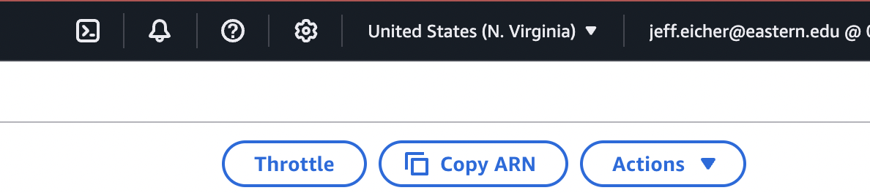

If any one screenshot is missing this identification, the entire assignment will be scored no higher than 70%.

Points totals are provided at the start of each question. You score either full credit or 0 points; there is no partial credit for each question.

Curtis Nielson
DTSC-671

- [5 points] In the space below, provide a screenshot of the image you selected and a description of where you found it (i.e., provide a website if you found the image online; or, if it’s your own picture, just let us know). The image should have multiple objects in it (at least three), rather than one single object.

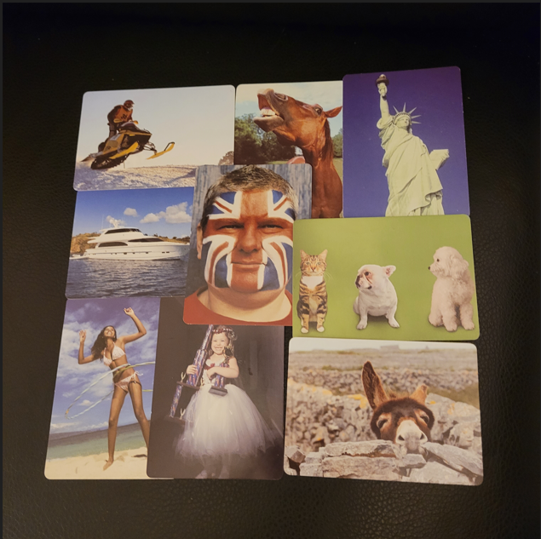

I made a collage of images from the game PicWits and took a picture of the result.
https://www.mindware.orientaltrading.com/picwits-a2-56002.fltr

I wanted to give Rekognition a challenge. Here is what it found.

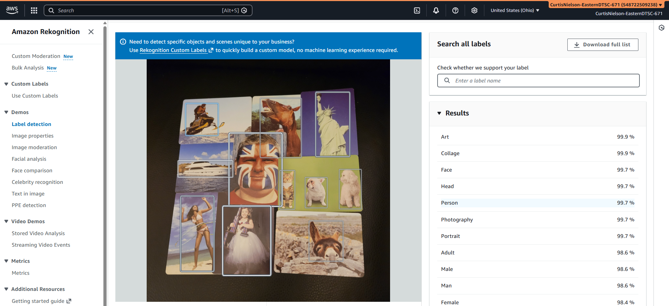

- [10 points] In the space below, provide a screenshot of the Lambda function diagram (with trigger and destination).

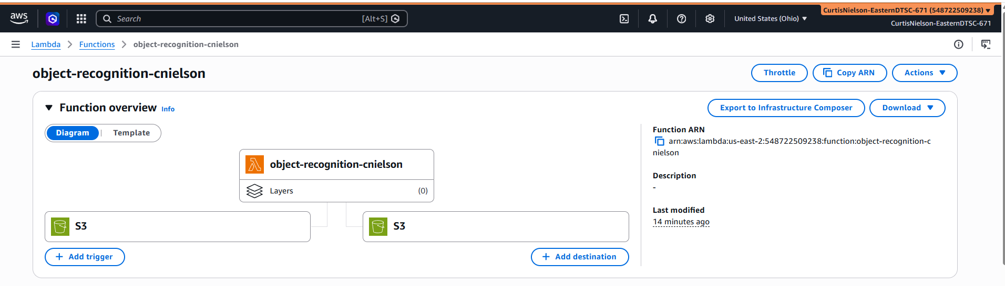

- [10 points] In the space below, provide both a screenshot of the beginning of your Lambda code with your account showing, then copy-paste your full lambda code below the screenshot.

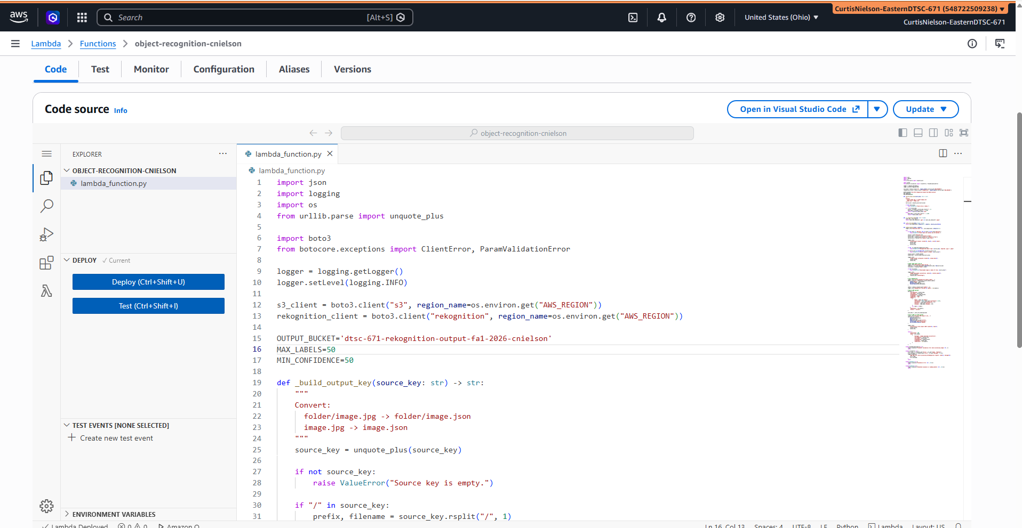

import json
import logging
import os
from urllib.parse import unquote_plus

import boto3
from botocore.exceptions import ClientError, ParamValidationError

logger = logging.getLogger()
logger.setLevel(logging.INFO)

s3_client = boto3.client("s3", region_name=os.environ.get("AWS_REGION"))
rekognition_client = boto3.client("rekognition", region_name=os.environ.get("AWS_REGION"))

OUTPUT_BUCKET='dtsc-671-rekognition-output-fa1-2026-cnielson'
MAX_LABELS=50
MIN_CONFIDENCE=50

def _build_output_key(source_key: str) -> str:
"""
Convert:
folder/image.jpg -> folder/image.json
image.jpg -> image.json
"""
source_key = unquote_plus(source_key)

if not source_key:
raise ValueError("Source key is empty.")

if "/" in source_key:
prefix, filename = source_key.rsplit("/", 1)
base_name = filename.rsplit(".", 1)[0]
return f"{prefix}/{base_name}.json"
else:
base_name = source_key.rsplit(".", 1)[0]
return f"{base_name}.json"

def _is_supported_image(key: str) -> bool:
lower_key = key.lower()
return lower_key.endswith(".jpg") or lower_key.endswith(".jpeg")

def _safe_json_dump(data: dict) -> str:
return json.dumps(data, default=str, indent=2, ensure_ascii=False)

def lambda_handler(event, context):
logger.info("Received event: %s", json.dumps(event, default=str))

try:
if not event or "Records" not in event or not event["Records"]:
raise ValueError("Event does not contain any S3 Records.")

record = event["Records"][0]
bucket_name = record["s3"]["bucket"]["name"]
source_key = unquote_plus(record["s3"]["object"]["key"])
source_size = record["s3"]["object"].get("size")

logger.info(
"Processing S3 object: bucket=%s, key=%s, size=%s bytes",
bucket_name,
source_key,
source_size,
)

if not _is_supported_image(source_key):
raise ValueError(f"Unsupported object type: {source_key}. Expected .jpg or .jpeg")

if source_size is not None and int(source_size) == 0:
raise ValueError(f"Source object is empty: {source_key}")

target_bucket = OUTPUT_BUCKET
output_key = _build_output_key(source_key)

logger.info(
"Target bucket configured: bucket=%s, output_key=%s",
target_bucket,
output_key,
)

# Read image bytes from S3
logger.info("Downloading image from S3...")
response = s3_client.get_object(Bucket=bucket_name, Key=source_key)
file_bytes = response["Body"].read()

if not file_bytes:
raise ValueError(f"Downloaded image is empty for key: {source_key}")

logger.info(
"Image downloaded successfully. bytes=%s, content_type=%s",
len(file_bytes),
response.get("ContentType"),
)

# Call Rekognition
logger.info("Calling Rekognition detect_labels...")
detect_response = rekognition_client.detect_labels(
Image={"Bytes": file_bytes},
MaxLabels=MAX_LABELS,
MinConfidence=MIN_CONFIDENCE,
)

labels = detect_response.get("Labels", [])
logger.info("Rekognition returned %s labels", len(labels))

# Build JSON payload
payload = {
"sourceBucket": bucket_name,
"sourceKey": source_key,
"targetBucket": target_bucket,
"targetKey": output_key,
"imageType": "jpg",
"labels": [
{
"Name": label.get("Name"),
"Confidence": float(label.get("Confidence", 0.0)),
"Instances": label.get("Instances", []),
"Parents": label.get("Parents", []),
"Aliases": label.get("Aliases", []),
}
for label in labels
],
"labelCount": len(labels),
"status": "success",
}

json_body = _safe_json_dump(payload)

# Write JSON to target bucket
logger.info("Writing JSON output to S3...")
s3_client.put_object(
Bucket=target_bucket,
Key=output_key,
Body=json_body.encode("utf-8"),
ContentType="application/json",
ServerSideEncryption="AES256",
)

logger.info(
"Successfully wrote output JSON: bucket=%s, key=%s",
target_bucket,
output_key,
)

return {
"statusCode": 200,
"body": json.dumps(
{
"message": "Image analyzed successfully",
"sourceBucket": bucket_name,
"sourceKey": source_key,
"targetBucket": target_bucket,
"targetKey": output_key,
"labelCount": len(labels),
}
),
}

except ParamValidationError as e:
logger.exception("Parameter validation error while processing image: %s", e)
raise

except ClientError as e:
error_code = e.response.get("Error", {}).get("Code", "Unknown")
error_message = e.response.get("Error", {}).get("Message", str(e))
logger.exception(
"AWS SDK error while processing S3/Rekognition request: code=%s, message=%s",
error_code,
error_message,
)
raise

except ValueError as e:
logger.exception("Validation error: %s", str(e))
raise

except Exception as e:
logger.exception("Unhandled exception in lambda_handler: %s", str(e))
raise

- [10 points] In the space below, provide a screenshot of the CloudWatch log streams for your Lambda function. Fit as many as you can in the screenshot.

I only needed one this time

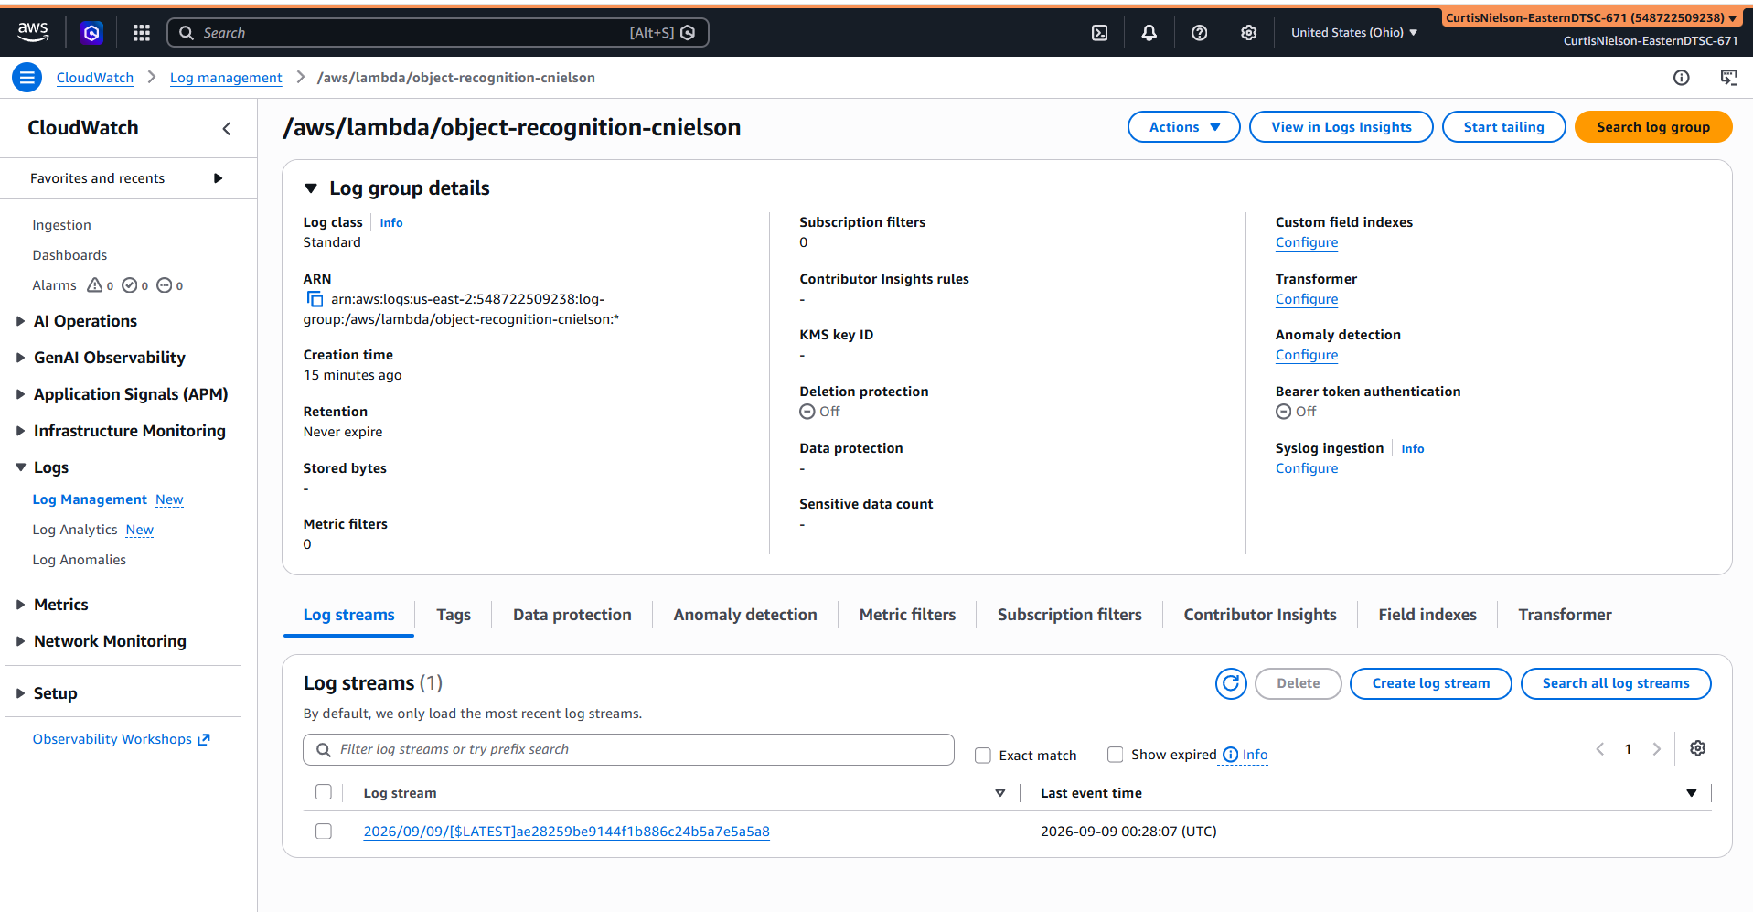

- [10 points] In the space below, provide a screenshot of the CloudWatch stream that functioned without errors.

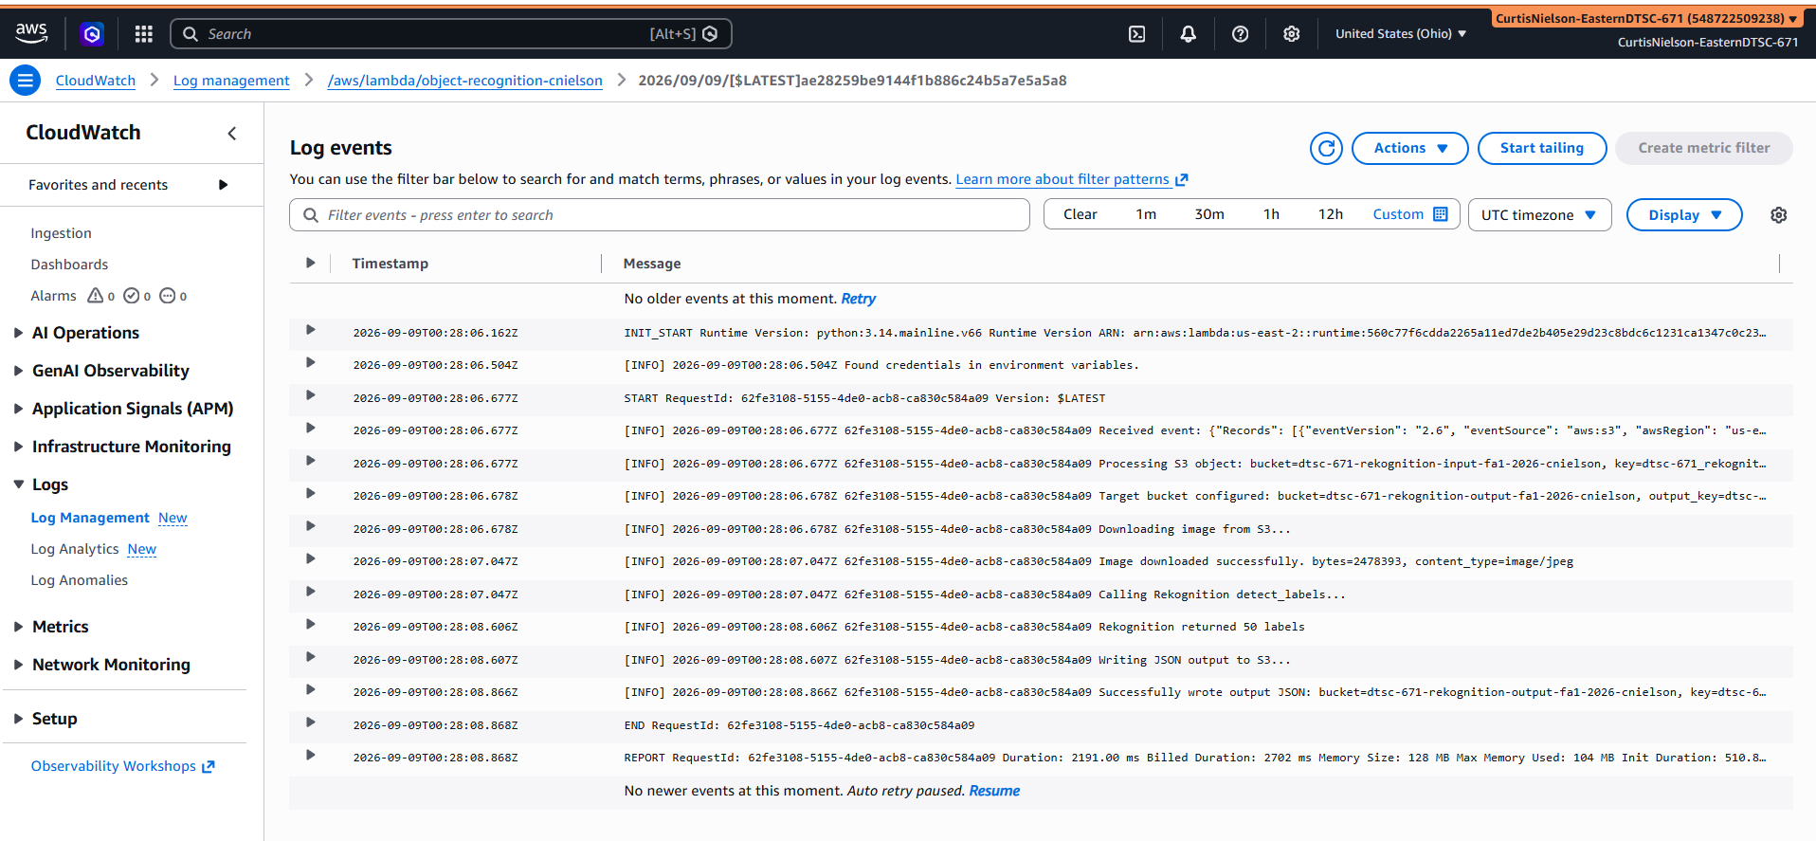

- [10 points] In the space below, provide a screenshot of IAM role permissions for the Lambda function.
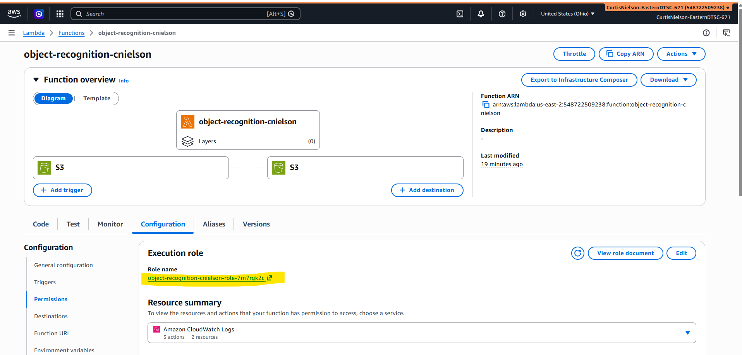
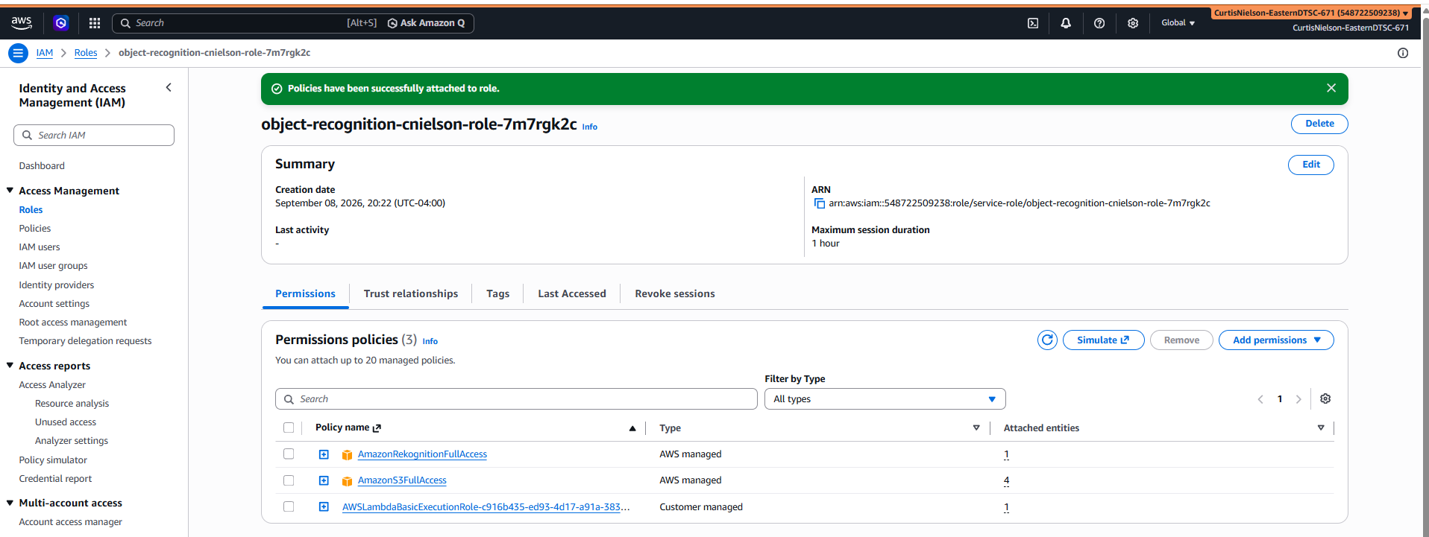

- [20 points] In the space below, provide a screenshot of the JSON file in your output bucket.

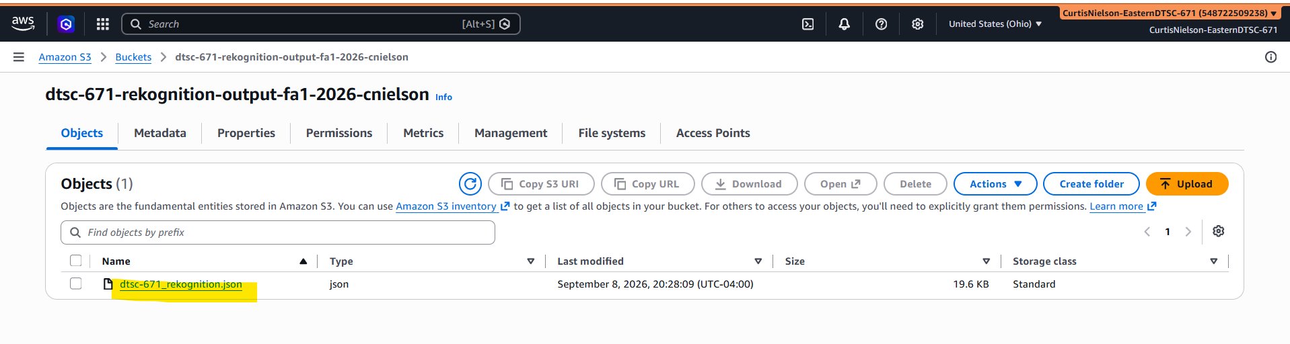

- [25 points] Provide a screenshot of your JSON file’s output (which shows labels and confidence). Fit as much as you can in the screenshot. We expect this information to match the image you provided above.

